

MEU Transportation

A Final Project Report
Submitted for Software Requirements Engineering Course & Software Design Course

-Faculty of Information Technology-

Submitted By:
Anas Hassan Abu Dahak 202310943
Mohammad Ali Atari 202311859
Mohammad Nader Al-Toubeh 202310949
Noor Shananeer 202310081
Sarah Shahrour 202311299

Under The Guidance Of:
Dr. Hani Albloush

Table Of Contents

Contents
Table Of Contents 2
Chapter 1 Introduction: 5
1.1 Purpose: 5
1.2 Scope: 5
1.3 Definitions, acronyms, and abbreviations: 6
1.4 Technology and tools to be used: 7
1.5 Project Scope: 9
1.6 Project Objective: 10
1.7 Software Process Model: 10
1.8 References: 11
1.9 Overview: 12
Chapter 2: Overall description: 12
2.1 Background of problem statement: 13
2.2 Problem statement: 13
2.2.1 Problem statement: 14
2.3 Significance of the problem: 15
2.4 Product perspective: 16
2.5 Product functions: 16
2.6 User characteristics: 16
2.7 Constraints: 17
2.8 Assumptions and dependencies: 18
Chapter 3: Specific requirements 19
3.1 Hardware interfaces 19
3.2 Software interfaces 19
3.3 Communications interfaces 19
3.4 Functional requirements: 20
3.4.1 User Class 1 - The Student: 20
3.4.2 User Class 2 – Driver: 22
3.4.3 User Class 3 - The Administrator: 24
3.5 Performance requirements: 31
3.4 Design constraints 32
3.5 Software system attributes 33
Chapter 4: Prioritization and Release Plan 36
4.1 Prioritization Criteria 36
4.2 Release Strategy 36
4.3 Release Plan 37
Chapter 5: Design 39
5.1 Use Cases Diagram: 39
5.2 Activity Diagram: 67
5.3 Domain Class Diagram: 70
5.4 Class Diagram: 77
5.5 Prototype: 80
References: 84

Chapter 1 Introduction:

This section gives a scope description and overview of everything included in this SRS document. Also, the purpose for this document is to be described and a list of abbreviations and definitions is provided.

1.1 Purpose:
The purpose of this document is to give a detailed description of the requirements for the “MEU Transportation System” software. It will illustrate the purpose and complete declaration for the development of system. It will also explain system constraints, interface and interactions with other external applications. This document is primarily intended to be proposed to a customer for its approval and a reference for developing the first version of the system for the development team.

1.2 Scope:
This project proposes the development of the MEU Transportation System, a mobile and web-based solution designed to enhance the daily commuting experience of students and staff at the Middle East University (MEU). The system aims to provide a seamless and user-friendly platform for accessing real-time transportation information.
Functionally, users can securely log in using their university credentials, recover forgotten passwords through their official university email, and sign out at any time. After logging in, users can choose between two main options: "To MEU" and "From MEU", which lead to a list of available routes. Each route displays essential information such as estimated arrival time, number of buses, and station details. Users can select a specific route to view in-depth details, including bus numbers, passenger counts, station schedules, and driver contact information. Additionally, a user account section offers personalized details and quick access to service features like rating and contacting the system operators.
From a non-functional perspective, the system prioritizes usability and performance. It features a bilingual (Arabic and English) interface tailored for university students, with real-time data updates, quick response times, and secure authentication protocols. The architecture supports modularity for easy maintenance, scalability to accommodate a growing user base, and 24/7 accessibility with defined maintenance windows.
By integrating modern UI/UX practices with robust back-end services, the MEU Transportation System seeks to improve mobility to and from campus, reduce uncertainty in transportation schedules, and foster a more connected campus environment.

1.3 Definitions, acronyms, and abbreviations:

Term | Definition
User | Someone who interacts with the mobile phone application
Admin/Administrator | System administrator who is given specific permission for managing and controlling the system
Restaurant Owner | Someone who has a restaurant and wants his restaurant to be a part the application
Web-Portal | A web application which present special facilities for admin
GPS | Global Positioning System
GPS-Navigator | An installed software on mobile phone which could provide GPS connection and data, show locations on map and find paths from current position to defined destination
Application Store | An installed application on mobile phone which helps user to find new compatible applications with mobile phone platform and download them from Internet
Stakeholder | Any person who interacts with the system who is not a developer.
DESC | Description
RAT | Rational
DEP | Dependency
TAG | A unique, persistent identifier contained in a PLanguage statement [2]
GIST | A short, simple description of the concept contained in a PLanguage statement [2]
SCALE | The scale of measure used by the requirement contained in a PLanguage statement [2]
METER | The process or device used to establish location on a SCALE contained in a PLanguage statement [2]
MUST | The minimum level required to avoid failure contained in a PLanguage statement [2]
PLAN | The level at which good success can be claimed contained in a PLanguage statement [2]
WISH | A desirable level of achievement that may not be attainable through available means contained in a PLanguage statement [2]
DEFINED | The official definition of a term contained in a PLanguage statement [2]

1.4 Technology and tools to be used:

The development of the MEU Transportation System will leverage a combination of modern technologies and tools to ensure a scalable, secure, and user-friendly solution. The system will be developed as a cross-platform application, accessible via mobile devices and potentially a web interface, with real-time capabilities and an intuitive UI.

1. Frontend Technologies
- Flutter (Dart): For building a cross-platform mobile application compatible with both Android and iOS devices, ensuring a consistent user experience with a single codebase.
- React (optional for Web): If a web-based admin panel is developed, react will be used for its speed, flexibility, and component-based architecture.
- Google Maps API: To integrate interactive maps, visualize routes, and show bus locations in real time.
2. Backend Technologies
- Node.js (Express.js): A lightweight and efficient backend framework used for building RESTful APIs and handling business logic.
- Firebase Realtime Database / Firestore: For storing and syncing data in real time across users, especially for tracking bus locations and passenger counts.
- Firebase Authentication: To manage user sign-in/sign-out securely and integrate password recovery features.
- Socket.IO (or Firebase Streams): For real-time communication between buses and users to push live location and status updates.
3. Database:
- NoSQL (Firebase Firestore or MongoDB): Offers flexibility in managing hierarchical route and bus data, enabling fast queries and scalability.
4. Admin Panel Tools
- React with Firebase Admin SDK: For creating a responsive and secure admin interface to manage drivers, routes, buses, and users.
- Chart.js or Recharts: For visualizing route usage data and bus occupancy stats in the admin dashboard.
5. Security & Deployment
- JWT (JSON Web Tokens): For secure user session management.
- Google Cloud / Firebase Hosting / Heroku: For deploying the backend and admin panel with scalability and reliability.
- SSL Encryption & Secure Email Verification: To ensure user data privacy, especially for password recovery via university email.
6. Version Control & Collaboration
- Git + GitHub: For source code management, version tracking, and team collaboration.
- Trello / Notion / Jira: For task management, sprint planning, and documentation.

Through these objectives, the project strives to bridge the gap between users and MEU's transportation services by leveraging modern digital tools to create a smarter and more connected campus mobility experience.

1.5 Project Scope:
The scope of the MEU Transportation System encompasses the design, development, deployment, and testing of a digital platform that facilitates and enhances the university’s internal transportation services. The system is aimed at students, staff, drivers, and administrators, and includes both user-facing and backend components.

In-Scope Features:
- User Authentication & Account Management
  - Secure login using username and password.
  - Password recovery via university email.
  - User profile page displaying name, major, and student number.
- Route & Bus Selection
  - Options for selecting trips “To MEU” or “From MEU”.
  - Display of available routes with route name, estimated time, number of buses, and stations.
  - Route-specific information including bus number, passenger count, station times, and driver contact.
- Real-Time Tracking & Information
  - Real-time or near-real-time updates of bus status and location.
  - Estimated arrival times at each station.
- User Interaction
  - Ability to rate the transportation service.
  - In-app contact options to call driver or transportation help.
  - Secure logout and session timeout functionality.
- Multilingual Support
  - Full Arabic and English language interface support.
- Admin Panel
  - Route, station, driver, and schedule management.
  - Dashboard with real-time data and analytics.
  - Role-based access for admin users.

Out of Scope:
- Payment integration or fare management.
- GPS hardware installation in buses (assumes GPS data is already available or externally provided).
- Desktop application version (initial release is mobile-first).
- Integration with external transportation providers or systems outside MEU.

1.6 Project Objective:
The objective of the MEU Transportation System project is to design and develop a smart, efficient, and user-friendly digital platform that enhances the transportation experience for Middle East University (MEU) students and staff. The system aims to simplify daily commuting by providing real-time bus information, route selection, and secure access to transportation services through a mobile application and an admin panel.
The specific goals include:

- Facilitating Seamless Commuting
Provide users with a simple interface to choose routes to or from MEU, view real-time bus locations, and access estimated arrival times.
- Ensuring Secure and Personalized Access
Implement user authentication, password recovery, and personal profile management to ensure security and customized experiences.
- Providing Real-Time Transportation Insights
Enable users to view detailed route information, including bus numbers, station times, and driver contact, updated in real-time or near-real-time.
- Enhancing Communication and Feedback
Allow users to rate the service, contact drivers, and easily manage their transportation preferences.
- Supporting Bilingual Accessibility
Ensure the system is fully accessible in both Arabic and English to accommodate all MEU community members.
- Laying a Foundation for Scalability
Develop a modular and scalable system that can grow with the university’s needs and support future feature expansions.

1.7 Software Process Model:

For the development of the MEU Transportation System, the Agile Software Development Model will be adopted. Agile is well-suited for this project because it supports iterative development, frequent feedback, and continuous improvement — all of which are essential for meeting evolving user needs in a university environment.

Why Agile?
- User-Centered Development: Agile allows the team to gather feedback from students, drivers, and administrators regularly, ensuring the system meets real user expectations.
- Flexibility and Adaptability: Requirements can be updated as the project progresses, which is crucial for handling real-time data integration and UI/UX refinement.
- Incremental Delivery: Features such as login, route selection, and bus tracking can be developed and tested in phases (sprints), reducing risk and improving quality.
- Team Collaboration: Agile encourages constant communication between developers, testers, and stakeholders, which enhances team productivity and alignment.
Agile Workflow Overview:
- Requirement Gathering & Backlog Creation
Functional and non-functional requirements are documented and prioritized.
- Sprint Planning
The team defines the tasks for each sprint (usually 1–2 weeks long).
- Design & Development
The system is built in small functional pieces, starting with core features like login, route display, and real-time tracking.
- Testing & QA
Each feature is tested at the end of every sprint to ensure reliability and usability.
- Review & Feedback
Stakeholders review progress and suggest improvements before the next sprint.
- Deployment & Maintenance
After final integration and testing, the system is deployed, with continuous updates based on user feedback.

1.8 References:
- IEEE Software Engineering Standards Committee, “IEEE Std 830-1998, IEEE Recommended Practice for Software Requirements Specifications”, October 20, 1998.
- Feldt R,”re_lecture5b_100914”, unpublished.
- Davis M A, “Just Enough Requirements Management: Where Software Development Meets Marketing”, New York, Dorset House Publishing, 2005.

Karlsson J, “A Cost-Value Approach for Prioritizing Requirements”, Norges Teknisk- Naturvitenskapelige Uni. 1997.

1.9 Overview:
The remainder of this document includes three chapters and appendixes. The second one provides an overview of the system functionality and system interaction with other systems. This chapter also introduces different types of stakeholders and their interaction with the system. Further, the chapter also mentions the system constraints and assumptions about the product.
The third chapter provides the requirements specification in detailed terms and a description of the different system interfaces. Different specification techniques are used in order to specify the requirements more precisely for different audiences.
The fourth chapter deals with the prioritization of the requirements. It includes a motivation for the chosen prioritization methods and discusses why other alternatives were not chosen.
The Appendixes in the end of the document include the all results of the requirement prioritization and a release plan based on them.
The primary objective of the MEU Transportation System project is to design and develop a smart, reliable, and user-friendly transportation platform tailored for the students and staff of Middle East University. The system aims to streamline daily commuting by providing real-time information on bus locations, routes, and schedules, while offering secure and intuitive access through mobile devices.

Chapter 2: Overall description:

This section will give an overview of the problem and the whole system. The system will be explained in its context to show how the system interacts with other systems and introduce the basic functionality of it. It will also describe what type of stakeholders that will use the system and what functionality is available for each type. At last, the constraints and assumptions for the system will be presented.

2.1 Background of problem statement:

Middle East University (MEU) serves a large and growing population of students, faculty, and staff, many of whom rely on university-provided transportation to commute between home and campus. Despite the availability of buses and predefined routes, the current transportation process lacks a centralized, digital solution to manage and communicate essential information in real-time. As a result, students often face issues such as uncertainty about bus arrival times, confusion regarding route details, overcrowding, and limited means to contact drivers or report problems.

The absence of a smart transportation system also leads to inefficiencies in how buses are allocated and utilized, resulting in wasted time and reduced satisfaction among commuters. Additionally, the lack of feedback mechanisms and route tracking makes it difficult for the university to monitor and improve transportation services based on actual user experience or operational data.

In today’s digital age, students expect intuitive, responsive, and mobile-friendly services that align with their fast-paced academic lifestyles. The gap between expectations and the current system creates frustration and negatively affects punctuality and productivity.
This project addresses these challenges by proposing a comprehensive transportation management system tailored specifically for MEU’s needs. By leveraging modern technologies such as real-time data updates, secure authentication, and user-focused design, the system aims to bridge the gap between MEU commuters and the transportation services provided to them.

2.2 Problem statement:

Students and staff at Middle East University currently face significant challenges in accessing and utilizing university transportation services due to the absence of a centralized, real-time, and user-friendly system. The lack of timely information on bus schedules, routes, and availability leads to confusion, delays, overcrowding, and dissatisfaction among users. Additionally, the existing system does not provide an efficient way to track buses, communicate with drivers, or receive updates, which limits the overall effectiveness and reliability of the transportation service.

There is a critical need for a digital platform that provides secure access, real-time route information, and a seamless user experience to improve commuting efficiency, enhance satisfaction, and support the growing demands of MEU’s transportation system.

2.2.1 Problem statement:

Transportation management systems (TMS) have become increasingly essential in modern urban and institutional settings, especially where there is a high density of daily commuters. Universities, in particular, have recognized the importance of integrating technology into campus transportation to address challenges such as overcrowding, inefficiency, and lack of real-time information. Numerous studies and existing solutions highlight the role of mobile and web-based platforms in improving public and institutional transport systems.

A study by Kumar & Bansal (2019) emphasized the effectiveness of real-time tracking and route optimization in improving user satisfaction and reducing waiting times. Their research on smart campus transportation systems concluded that GPS-enabled buses combined with mobile applications significantly enhance the commuting experience for students. Similarly, Zhang et al. (2020) investigated the impact of user-centric transportation applications in university environments, showing that systems providing personalized route information and notifications led to improved punctuality and decreased stress among students.

Commercial solutions such as Uber, Careem, and Google Maps have set high expectations among users regarding real-time updates, intuitive interfaces, and multilingual support. These platforms highlight the need for seamless user experiences, which are now seen as benchmarks even for institutional systems. Their success demonstrates the importance of fast response times, real-time data integration, and easy access to route and driver information—features highly relevant to the MEU Transportation System.

In the academic context, several universities have begun deploying mobile transportation apps. For example, the University of Michigan developed a student-focused transport app offering route schedules, live bus tracking, and notifications. A report by Ahmed et al. (2021) reviewed these systems and concluded that security, scalability, and bilingual support are critical features that determine their long-term usability and success.

Despite the availability of such technologies globally, many institutions in the MENA region, including Middle East University, still rely on traditional or manual approaches to manage transportation. This gap presents an opportunity to design a tailored system that addresses MEU’s specific needs while incorporating the best practices identified in the literature—such as real-time updates, user authentication, modular design, and accessibility.

Therefore, this project builds upon existing knowledge while aiming to fill a contextual gap through a solution adapted for MEU’s infrastructure, culture, and student expectations.

2.3 Significance of the problem:

The development of the MEU Transportation System holds significant value for both the university and its community. By introducing a centralized, real-time platform for managing and accessing transportation services, the project directly addresses key challenges related to daily commuting. It enhances the overall student and staff experience by reducing wait times, improving route visibility, and enabling better planning for campus arrivals and departures.
From an institutional perspective, the system supports more efficient utilization of transportation resources by providing valuable data on bus usage, passenger counts, and route performance. This data can inform future decisions about route optimization, fleet management, and service expansion as the university continues to grow.
Additionally, the system promotes safety and accountability through features such as driver contact access, real-time location tracking, and secure user authentication. The bilingual interface ensures accessibility for both Arabic and English-speaking users, making it inclusive and user-friendly.
Overall, the MEU Transportation System contributes to a smarter, more connected campus environment and reflects the university’s commitment to leveraging technology for operational excellence and student satisfaction.

2.4 Product perspective:
The University Bus System is a standalone solution created specifically for Middle East University (MEU). It consists of three main components:
A mobile app for students (iOS & Android)
A mobile app for drivers (iOS & Android)
A web-based admin panel for university staff
The system is designed to automate and simplify the transportation process without the need for manual reservations. It includes a smart counting mechanism that automatically tracks the number of students boarding or exiting a bus using onboard scanners or sensors.

2.5 Product functions:
- Student App
- Login with student credentials
- View real-time bus schedules and routes
- Live bus tracking on a map
- Receive notifications about bus status or delays
- Automatic seat count update upon boarding
- Driver App
- Login with driver credentials
- View daily trip assignments
- Start/end trips
- Access route navigation
- Auto-update number of students onboard
- Admin Panel
- Manage student and driver profiles
- Create and update bus routes and schedules
- Monitor real-time bus activity
- View usage statistics and reports
- Send notifications to students or drivers

2.6 User characteristics:
There are three types of users that interact with the system: users of the mobile application (Students and Bus Drivers), and administrators. Each of these three types of users has different use of the system so each of them has their own requirements.
The mobile application users can only use the application to interact with the system. This means that the users have to be able to search for stop stations and, and then navigate to it. In order for the users to get a relevant search result there are multiple criteria the users can specify and all results matches all of those.
The administrators also only interact with the web portal. They are managing the overall system so there is no incorrect information within it. The administrator can manage the information for each trip as well as the options for both mobile application users.

3. User Characteristics
Students (Regular users): -
Moderate technical proficiency.
Need a simple and easy-to-navigate interface.
Use the app mainly for tracking and notifications.
Drivers: -
May have basic smartphone skills.
Require a minimal interface to avoid distraction while driving.
Focus on route info and passenger count.
Admin Staff: -
Technically skilled users.
Responsible for managing the system and monitoring operations.
Use the admin dashboard for scheduling, tracking, and reporting.

2.7 Constraints:
The mobile application is constrained by the system interface to the GPS navigation system within the mobile phone. Since there are multiple system and multiple GPS manufacturers, the interface will most likely not be the same for every one of them. Also, there may be a difference between what navigation features each of them provides.
The Internet connection is also a constraint for the application. Since the application fetches data from the database over the Internet, it is crucial that there is an Internet connection for the application to function.
Both the web portal and the mobile application will be constrained by the capacity of the database. Since the database is shared between both application it may be forced to queue incoming requests and therefore increase the time it takes to fetch data.

2.8 Assumptions and dependencies:
Assumptions:
Students and drivers will have access to smartphones with internet connectivity.
All buses will be equipped with a working scanner or smart sensor to detect and count passengers automatically.
The university provides accurate route and schedule data to be entered into the system initially.
Notifications will be delivered through push notifications, assuming users allow notification permissions.
The system will be hosted on a stable server with proper security and backup policies in place.
Internet connection is available on buses for real-time data synchronization (via mobile data or Wi-Fi).

Dependencies:
Mobile platforms: The mobile apps depend on Android and iOS operating systems.
Hardware sensors or scanners: Automatic counting depends on proper functioning of onboard hardware.
Google Maps API (or similar): For real-time tracking and route visualization.
Backend infrastructure: The system depends on a cloud-based backend or university servers for data storage and communication.
Authentication system: The app relies on the university’s student and staff login credentials for secure access.
Notification service: Requires integration with Firebase Cloud Messaging (FCM) or a similar service for alerts.

Chapter 3: Specific requirements

This section contains all the functional and quality requirements of the system. It gives a detailed description of the system and all its features.

3.1 Hardware interfaces

The administrator application only works on PC, while the student and driver application work on phone. It also requires a sensor attached to the buses doors to determine the number of live passengers.

3.2 Software interfaces
The mobile application communicates with the GPS application in order to get geographical information about where the user is located and the visual representation of it, and with the database in order to get information and updates from Administrator. The communication between the database and the web portal consists of operation concerning both reading and modifying the data, while the communication between the database and the mobile application consists of only reading operations.

3.3 Communications interfaces
The communication between the different parts of the system is important since they depend on each other. However, in what way the communication is achieved is not important for the system and is therefore handled by the underlying operating systems for both the mobile application and the web portal.

3.4 Functional requirements:
This section includes the requirements that specify all the fundamental actions of the software system.

3.4.1 User Class 1 - The Student:

3.4.1.1 Functional Requirement 1.1
ID: FR1
TITLE: User Authentication
DESC: A student must be able to log in using a valid username and password.
RAT: In order for a student to access the application.
DEP: None

3.4.1.2 Functional Requirement 1.2
ID: FR2
TITLE: User Verification
DESC: If the student forgets their password, they can press the "Forgot Password" option, and the system sends a verifying code via University email.
RAT: In case of forgotten credentials.
DEP: FR1

3.4.1.3 Functional Requirement 1.3
ID: FR3
TITLE: Dashboard
DESC: Upon login, the system displays a dashboard. The student can choose one of two sections: "To MEU" or "From MEU."
RAT: To provide a user interface after successful login.
DEP: FR1

3.4.1.4 Functional Requirement 1.4
ID: FR4
TITLE: Schedule Management
DESC: If a student selects "From MEU," the system shows the bus schedule published by the administrator. Students can easily go to their buses after seeing their bus number.
RAT: To manage and display schedules.
DEP: FR1

3.4.1.5 Functional Requirement 1.5
ID: FR5
TITLE: Map and Route Features
DESC: If a student selects "To MEU," the system shows an interactive map. Students can press the search option to open a search menu. They can select a route and view bus/stop stations. The system displays detailed information about the selected bus route. Pressing on the bus or stop station icon shows all information about it. Pressing on the location icon (actor icon) shows all information about the time to reach the nearest station from the student's location.
RAT: To provide navigation and route details.
DEP: FR1

3.4.1.6 Functional Requirement 1.6
ID: FR6
TITLE: Student Info Option and Hamburger Icon
DESC: Students can edit their personal details via the student profile, such as student number, major, home location, and profile picture. The hamburger icon features include "Rate Us," "Call Us," and "Sign Out." Students can get help by using one of these options.
RAT: To manage student profiles and provide additional support options.
DEP: FR1

3.4.2 User Class 2 – Driver:

3.4.2.1 Functional Requirement 2.1
ID: FR7
TITLE: User Authentication
DESC: A driver must be able to log in using a valid username and password after receiving valid credentials.
RAT: In order for a driver to access the application.
DEP: None

3.4.2.2 Functional Requirement 2.2
ID: FR8
TITLE: User Verification
DESC: If the driver forgets their password, they can press the "Forgot Password" option, and the system sends a verifying code via their personal email.
RAT: In case of forgotten credentials.
DEP: FR7

3.4.2.3 Functional Requirement 2.3
ID: FR9
TITLE: Dashboard and Status Management
DESC: Upon login, the system displays a dashboard. Drivers can toggle their status (Active/Inactive).
RAT: To provide a user interface and manage driver status.
DEP: FR7

3.4.2.4 Functional Requirement 2.4
ID: FR10
TITLE: Trip Management
DESC: The dashboard also displays a list of assigned trips/tasks that have been assigned by the administrator. Drivers can press on tasks to view more information and trip details. When the system displays task information, drivers can initiate the trip by pressing the "Begin Trip" button.
RAT: To manage and display assigned trips.
DEP: FR7

3.4.2.5 Functional Requirement 2.5
ID: FR11
TITLE: Navigation and Tracking (To MEU)
DESC: Once a trip begins, a navigation dashboard appears with real-time tracking. The dashboard shows the live route, next station, live record of passengers, and map progress. Drivers can end the trip upon arrival at MEU.
RAT: To provide navigation and real-time tracking during trips.
DEP: FR10

3.4.2.6 Functional Requirement 2.6
ID: FR12
TITLE: Driver Profile and Task Actions Menu
DESC: Drivers can edit their personal details via the driver menu. Drivers can also report problems from the menu.
RAT: To manage driver profiles and report issues.
DEP: FR7

3.4.2.7 Functional Requirement 2.7
ID: FR13
TITLE: Navigation and Tracking (From MEU)
DESC: Once a trip begins, the same progress as point 5 applies. Drivers can end the trip when all passengers are delivered and all stop stations have been visited.
RAT: To provide navigation and real-time tracking during trips back from MEU.
DEP: FR10

3.4.3 User Class 3 - The Administrator:

3.4.3.1 Functional Requirement 3.1
ID: FR14
TITLE: Authentication
DESC: The administrator can log in using a username and password. A "Forgot Password" option is available for password recovery.
RAT: To ensure only authorized users access the system.
DEP: None

3.4.3.2 Functional Requirement 3.2
ID: FR15
TITLE: Logout Functionality
DESC: The administrator can log out from the system using the "Sign Out" button.
RAT: To securely end the session after use.
DEP: FR14

3.4.3.3 Functional Requirement 3.3
ID: FR16
TITLE: Dashboard Overview
DESC: Displays real-time locations of buses on a map. Shows bus routes and stop stations. Allows searching for specific buses or regions.
RAT: To provide an overview of the system's current status.
DEP: FR14

3.4.3.4 Functional Requirement 3.4
ID: FR17
TITLE: Map-Based Visualization
DESC: Interactive map showing live bus locations. Markers indicate bus positions and stops. Ability to zoom and pan the map.
RAT: To enable visual monitoring of bus locations and movements.
DEP: FR16

3.4.3.5 Functional Requirement 3.5
ID: FR18
TITLE: Search Functionality
DESC: Search bar to find specific buses or regions. Filters results based on search queries.
RAT: To help administrators quickly locate buses or areas of interest.
DEP: FR16

3.4.3.6 Functional Requirement 3.6
ID: FR19
TITLE: Bus List Management
DESC: Displays a table with details of all buses including: Bus Number, Destination, Next Trip Time, Capacity, Live Passengers, Notes, and Traffic Violations.
RAT: To provide detailed information about each bus.
DEP: FR14

3.4.3.7 Functional Requirement 3.7
ID: FR20
TITLE: Edit Bus Details
DESC: Administrators can edit bus details such as destination, trip time, capacity, live passengers, and add notes like "Needs to refill diesel."
RAT: To allow updates to bus-related data.
DEP: FR19

3.4.3.8 Functional Requirement 3.8
ID: FR21
TITLE: Real-Time Tracking
DESC: Live location tracking of buses on the map. Displays current route and stop stations.
RAT: To monitor ongoing operations and manage logistics.
DEP: FR17

3.4.3.9 Functional Requirement 3.9
ID: FR22
TITLE: Driver List Management
DESC: Displays a table with driver details including: Name, Phone Number, Status (Active/Inactive), and Notes.
RAT: To provide detailed information about each driver.
DEP: FR14

3.4.3.10 Functional Requirement 3.10
ID: FR23
TITLE: Driver Profile
DESC: Clicking on a driver’s name opens their profile page which includes: Name, Phone Number, Status, and Tasks for today (destination, trip time, bus number).
RAT: To provide more detailed information about individual drivers.
DEP: FR22

3.4.3.11 Functional Requirement 3.11
ID: FR24
TITLE: Driver Communication
DESC: Administrators can call drivers directly by clicking an icon next to their phone number.
RAT: To facilitate direct communication between administrators and drivers.
DEP: FR22

3.4.3.12 Functional Requirement 3.12
ID: FR25
TITLE: Task Management
DESC: Administrators can set and modify tasks for drivers, including trip schedules and destinations.
RAT: To assign and manage daily driving duties.
DEP: FR22

3.4.3.13 Functional Requirement 3.13
ID: FR26
TITLE: Current Trips Monitoring
DESC: Displays ongoing trips with details: Destination, Bus Number, Time to reach, Live Record of Passengers, Current Location, and Option to call the driver.
RAT: To monitor active trips and respond to issues if needed.
DEP: FR14

3.4.3.14 Functional Requirement 3.14
ID: FR27
TITLE: Previous Trips Records
DESC: Displays historical data of completed trips including: Destination, Bus Number, Trip Date, Trip Time, Passenger Count, and Option to call the driver.
RAT: To keep track of past trips for auditing and reporting purposes.
DEP: FR14

3.4.3.15 Functional Requirement 3.15
ID: FR28
TITLE: Add Schedule
DESC: Administrators can add new trip schedules, specifying: Trip time, Destination, and Bus number.
RAT: To plan and schedule future trips.
DEP: FR14

3.4.3.16 Functional Requirement 3.16
ID: FR29
TITLE: Profile Management
DESC: Administrators can change their profile picture, update username, email, phone number, change password, and select language preferences.
RAT: To customize and manage user account settings.
DEP: FR14

3.4.3.17 Functional Requirement 3.17
ID: FR30
TITLE: System Configuration
DESC: Options to configure system-wide settings (e.g., general settings, notifications, etc.).
RAT: To adjust application behavior according to organizational needs.
DEP: FR14

3.4.3.18 Functional Requirement 3.18
ID: FR31
TITLE: Real-Time Data Updates
DESC: Provides real-time updates for: Bus locations, passenger counts, trip statuses, and driver availability.
RAT: To ensure accurate and up-to-date operational awareness.
DEP: FR14

3.4.3.19 Functional Requirement 3.19
ID: FR32
TITLE: Notifications
DESC: Alerts for critical issues such as low fuel levels, traffic violations, or delays.
RAT: To notify administrators of urgent situations requiring attention.
DEP: FR31

3.4.3.20 Functional Requirement 3.20
ID: FR33
TITLE: Reporting and Analytics
DESC: View past trips and passenger records. Generate reports for analysis of performance metrics such as bus utilization, driver performance, and trip efficiency.
RAT: To support decision-making and performance evaluation.
DEP: FR14

3.4.3.21 Functional Requirement 3.21
ID: FR34
TITLE: Security Features
DESC: Includes strong password policies, secure data transmission and storage (encryption), and audit logs to track changes made by administrators.
RAT: To protect sensitive data and ensure accountability.
DEP: FR14

3.5 Performance requirements:
The requirements in this section provide a detailed specification of the user interaction with the software and measurements placed on the system performance.

Response time
TAG: Response Time
GIST: The fastness of the search
SCALE: The response time of a search
METER: Measurements obtained from 1000 searches during testing.
MUST: No more than 2 seconds 100% of the time.
WISH: No more than 1 second 100% of the time.

System dependability
TAG: System Dependability
GIST: The fault tolerance of the system.
SCALE: If the system loses the connection to the Internet or to the GPS device or the system gets some strange input, the user should be informed.
METER: Measurements obtained from 1000 hours of usage during testing. MUST: 100% of the time.
Facilitating Seamless Commuting
Provide users with a simple interface to choose routes to or from MEU, view real-time bus locations, and access estimated arrival times.
Ensuring Secure and Personalized Access
Implement user authentication, password recovery, and personal profile management to ensure security and customized experiences.
Providing Real-Time Transportation Insights
Enable users to view detailed route information, including bus numbers, station times, and driver contact, updated in real-time or near-real-time.
Enhancing Communication and Feedback
Allow users to rate the service, contact drivers, and easily manage their transportation preferences.
Supporting Bilingual Accessibility
Ensure the system is fully accessible in both Arabic and English to accommodate all MEU community members.
Laying a Foundation for Scalability
Develop a modular and scalable system that can grow with the university’s needs and support future feature expansions.

3.4 Design constraints
This section includes the design constraints on the software caused by the hardware.
3.4.1 Hard drive space
TAG: HardDriveSpace
GIST: Hard drive space.
SCALE: The application’s need of hard drive space.
METER: MB.
MUST: No more than 20 MB. PLAN: No more than 15 MB. WISH: No more than 10 MB. MB: DEFINED: Megabyte
3.4.2 Application memory usage
TAG: ApplicationMemoryUsage
GIST: The amount of Operate System memory occupied by the application.
SCALE: MB.
METER: Observations done from the performance log during testing MUST: No more than 20 MB.
PLAN: No more than 16 MB
WISH: No more than 10 MB
Operate System: DEFINED: The mobile Operate System which the application is running on. MB: DEFINED: Megabyte.

3.5 Software system attributes
The requirements in this section specify the required reliability, availability, security and maintainability of the software system.
3.5.1 Reliability
TAG: SystemReliability
GIST: The reliability of the system.
SCALE: The reliability that the system gives the right result on a search.
METER: Measurements obtained from 1000 searches during testing.
MUST: More than 98% of the searches. PLAN: More than 99% of the searches. WISH: 100% of the searches.
3.5.2 Availability
TAG: SystemAvailability
GIST: The availability of the system when it is used.
SCALE: The average system availability (not considering network failing). METER: Measurements obtained from 1000 hours of usage during testing.
MUST: More than 98% of the time.
PLAN: More than 99% of the time. WISH: 100% of the time.
TITLE: Internet Connection
DESC: The application should be connected to the Internet.
RAT: In order for the application to communicate with the database.
DEP: none

TITLE: GPS Connection
DESC: The application should be connected to the GPS device.
RAT: In order for the application to get the users location, the map and to calculate the distance.
DEP: none
3.5.3 Security
TAG: CommunicationSecurity
GIST: Security of the communication between the system and server.
SCALE: The messages should be encrypted for log-in communications, so others cannot get user-name and password from those messages.
METER: Attempts to get user-name and password through obtained messages on 1000 log-in session during testing.
MUST: 100% of the Communication Messages in the communication of a log-in session should be encrypted.
Communication Messages: Defined: Every exchanged of information between client and server.
TAG: StudentLoginAccountSecurity
GIST: Security of accounts.
SCALE: If Student tries to log in to the app with a non-existing account then the student should not be logged in. The admin should be notified about log-in failure.
METER: 1000 attempts to log-in with a non-existing user account during testing. MUST: 100% of the time.

TAG: AdminLoginAccountSecurity
GIST: Security of accounts.
SCALE: If an admin tries to log in to the web portal with a non-existing account then the admin should not be logged in. The admin should be notified about log-in failure.
METER: 1000 attempts to log-in with a non-existing user account during testing. MUST: 100% of the time.

TAG: UserCreateAccountSecurity
GIST: The security of creating account for users of the system.
SCALE: If a user wants to create an account and the desired user name is occupied, the user should be asked to choose a different user name.
METER: Measurements obtained on 1000 hours of usage during testing. MUST: 100% of the time.

3.5.4 Maintainability

TITLE: Application extendibility
DESC: The application should be easy to extend. The code should be written in a way that it favors implementation of new functions.
RAT: In order for future functions to be implemented easily to the application.
DEP: none

TITLE: Application testability
DESC: Test environments should be built for the application to allow testing of the application’s different functions.
RAT: In order to test the application.
DEP: none
3.5.5 Portability
TITLE: Application portability
DESC: The application should be portable with iOS and Android.
RAT: The adaptable platform for the application to run on.
DEP: none

Chapter 4: Prioritization and Release Plan

4.1 Prioritization Criteria

The prioritization of features and use cases for the Transportation System was based on the following factors:

- Business Value: Features that enable core functionality and meet immediate stakeholder needs.

- User Impact: Features that directly improve the user experience for students, drivers, and admins.

- Technical Dependencies: Features that need to be in place before others can function.

- Development Complexity: Balance between high-value and low-effort items.

- Risk Management: Early delivery of high-risk or high-uncertainty features to test feasibility.

4.2 Release Strategy
The project will follow a phased incremental release strategy, where essential features are delivered in the earliest release, followed by iterative enhancements.

4.3 Release Plan

Release | Features Included | Description
v1.0 - Core MVP | - Student Mobile App (basic booking, view routes)  - Driver Mobile App (view assigned route, check-in/out)  - Admin Panel (login, add routes & buses) | Focus on delivering basic transportation flow for students and drivers with limited admin control. Critical to test and validate user experience and technical performance.
v1.1 - Usability Upgrade | - Real-time location tracking  - Push notifications  - Rate Us / Call Us (from menu)  - Improved UI/UX (maps and menus) | Enhances the usability and adds dynamic features like location visibility and communication options.
v1.2 - Advanced Admin Tools | - Driver scheduling  - Route analytics dashboard  - View logs and reports  - User management | Empowers the admin with more data control and monitoring. Improves operations and decision-making capabilities.
v2.0 - Full Deployment | - Feedback and support system  - In-app language toggle  - Accessibility improvements  - Bug fixes and optimization | Comprehensive system refinement based on user feedback and analytics data. Ready for long-term use and scaling.

4.4 Feature Prioritization Matrix:

Feature | Priority | Stakeholder | Reason
Route selection & booking (student) | High | Students
  Core usage scenario
 | High | Drivers
  Driver check-in/out
  Operational need
 | High | Admin
  Route creation (admin)
  System backbone
Location tracking | Medium | All Users | Adds transparency and trust
 | Medium | Students, Drivers
  Push notifications
  Communication aid
 | Low | Admin | Long-term optimization
  Analytics dashboard

Chapter 5: Design

5.1 Use Cases Diagram:

Student Use Case:
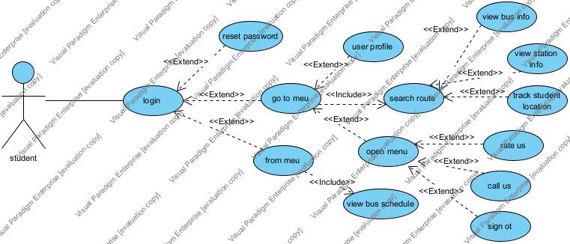

Driver Use Case:

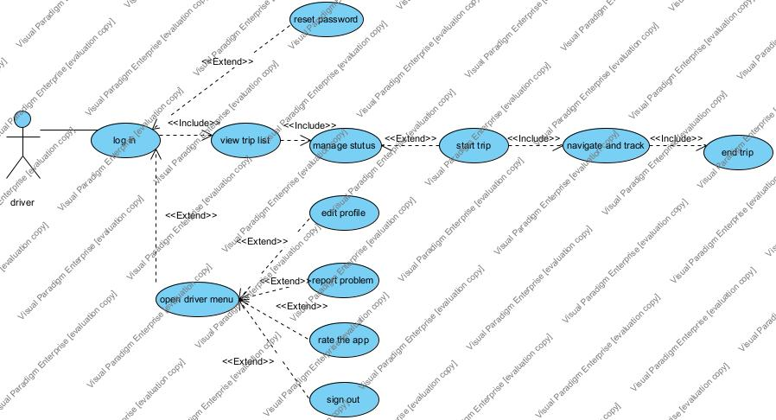

Admin Use Case:

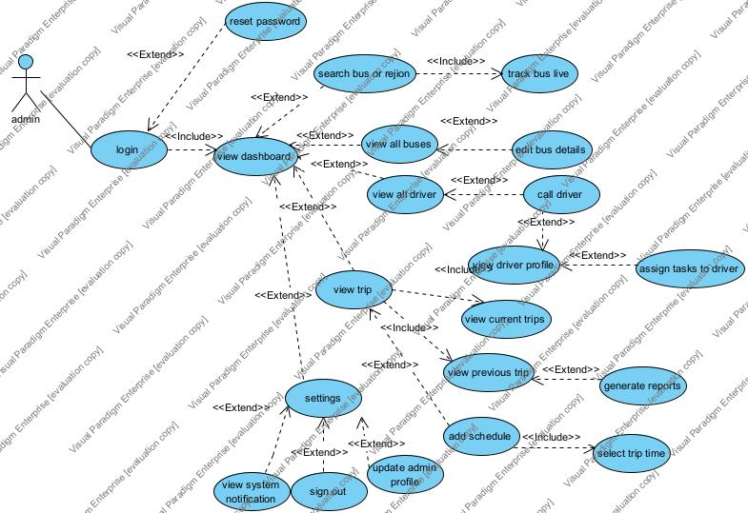

5.2 Activity Diagram:

Student app use case description
1. log in
Use Case ID | UC001
Use Case Name | log in
Created By | Noor shananeer
Date Created | 29/5/2025
Brief Description | Allows the student to securely access the application using their username and password.
Primary Actor | Student
Secondary Actor | -
Pre-condition | The user has a valid account (username and password).
Post-Condition | The student is redirected to the dashboard.
Main Flows | 1. The student opens the app.  2. The login screen appears.  3. The student enters their username and password.  4. The student clicks the “Login” button.  5. The system verifies the credentials.  6. If correct, the system shows the dashboard.
Alternative Flow | 3a. If credentials are invalid:  • System displays error message: “Invalid username or password”.  • Returns to step 2.

2. reset password
Use Case ID | UC002
Use Case Name | reset password
Created By | Noor shananeer
Date Created | 29/5/2025
Brief Description | Enables students who forgot their password to reset it through email verification.
Primary Actor | Student
Secondary Actor | -
Pre-condition | • The student has forgotten their password.  • The student has a valid university email address.
Post-Condition | A verification code is sent to the student’s email.
Main Flows | 1. The student clicks “Forgot Password”.  2. The system asks for the university email.  3. The student enters the email.  4. The system sends verification code.  5. The student uses the code to reset the password.
Alternative Flow | • 2a. If email is invalid:  • System shows error: “Invalid university email”.  • Returns to step 2.

3. go to MEU
Use Case ID | UC003
Use Case Name | go to MEU
Created By | Sarah shahrour
Date Created | 29/5/2025
Brief Description | Displays an interactive map of routes to MEU.
Primary Actor | Student
Secondary Actor | -
Pre-condition | The student is logged in.
Post-Condition | A map with relevant route info is displayed.
Main Flows | 1. The student selects the “To MEU” option.  2. A map appears.  3. They can search for the route and view bus info.

4. Go from MEU
Use Case ID | UC004
Use Case Name | Go from MEU
Created By | Mohamad atari
Date Created | 29/5/2025
Brief Description | Shows a schedule of buses departing from MEU to different areas.
Primary Actor | Student
Secondary Actor | -
Pre-condition | The student is logged in.
Post-Condition | The schedule table is shown.
Main Flows | 1. The student selects “From MEU”.  2. The system displays the list of bus times.

5. Search Route
Use Case ID | UC005
Use Case Name | Search Route
Created By | Mohamad atari
Date Created | 29/5/2025
Brief Description | Allows the student to search for a route to or from the university.
Primary Actor | Student
Secondary Actor | -
Pre-condition | “To MEU” is selected
Post-Condition | The route and its details are displayed.
Main Flows | 1. The student enters the area name.  2. The system shows the path, time, and number of stops.
Alternative Flow | If no route is found, a message is shown.

6. View Bus Info
Use Case ID | UC006
Use Case Name | View Bus Info
Created By | Anas hasan
Date Created | 29/5/2025
Brief Description | Displays detailed bus information such as number of passengers and arrival time.
Primary Actor | Student
Secondary Actor | -
Pre-condition | A route is selected.
Post-Condition | Bus information is displayed.
Main Flows | 1. The student selects a bus icon on the map.  2. Details like capacity, ETA, and current status are shown.

7. View Station Info
Use Case ID | UC007
Use Case Name | View Station Info
Created By | Anas hasan
Date Created | 29/5/2025
Brief Description | Shows information about the nearest station to the students.
Primary Actor | Student
Secondary Actor | -
Pre-condition | The station icon is clicked.
Post-Condition | Station information is displayed.
Main Flows | 1. The student clicks on a station icon.  2. Station names and arrival times are shown.

8. Track Student Location
Use Case ID | UC008
Use Case Name | Track Student Location
Created By | Mohammad Altoubeh
Date Created | 29/5/2025
Brief Description | Detects the student’s location to show the nearest station or bus.
Primary Actor | Student
Secondary Actor | -
Pre-condition | Location permission is enabled.
Post-Condition | Nearest stop and arrival time are shown.
Main Flows | 1. The student clicks the location icon.  2. The system shows the closest station and bus info.

9. View Buses Schedule
Use Case ID | UC009
Use Case Name | View Buses Schedule
Created By | Mohammad Altoubeh
Date Created | 29/5/2025
Brief Description | Displays a full schedule of buses leaving MEU.
Primary Actor | Student
Secondary Actor | -
Pre-condition | “From MEU” option is selected.
Post-Condition | The bus schedule is displayed.
Main Flows | 1. The student clicks on the schedule option.  2. The full list of routes, areas, and times is shown.

10. user Profile
Use Case ID | UC010
Use Case Name | User profile
Created By | Noor shananeer
Date Created | 29/5/2025
Brief Description | Allows the student to update personal info like name, major, and address.
Primary Actor | Student
Secondary Actor | -
Pre-condition | The student is logged in and opens their profile.
Post-Condition | Changes are saved.
Main Flows | 1. The student opens their profile.  2. Edits the desired fields.  3. Saves the changes.

11. Open Menu
Use Case ID | UC011
Use Case Name | Open Menu
Created By | Noor shananeer
Date Created | 29/5/2025
Brief Description | Displays a sidebar menu with options like rating, contact, and logout.
Primary Actor | Student
Secondary Actor | -
Pre-condition | The student is logged into the app.
Post-Condition | Menu is shown.
Main Flows | 1. The student taps the menu icon.  2. The sidebar appears with different actions.

12. Rate Us
Use Case ID | UC012
Use Case Name | Rate Us
Created By | Sarah shahrour
Date Created | 29/5/2025
Brief Description | Allows the student to submit a rating for the app.
Primary Actor | Student
Secondary Actor | -
Pre-condition | The sidebar menu is opened.
Post-Condition | Rating is submitted to the system.
Main Flows | 1. The student selects “Rate Us”.  2. Gives a star rating and submits it.

13. Call Us
Use Case ID | UC013
Use Case Name | Call Us
Created By | Sarah shahrour
Date Created | 29/5/2025
Brief Description | Displays a phone number to contact the responsible party.
Primary Actor | Student
Secondary Actor | -
Pre-condition | The sidebar menu is opened.
Post-Condition | Contact info is displayed.
Main Flows | 1. The student selects “Call Us”.  2. The app shows the phone number to call.

14. Sign Out
Use Case ID | UC014
Use Case Name | Sign Out
Created By | Sarah shahrour
Date Created | 29/5/2025
Brief Description | Logs the student out of the application.
Primary Actor | Student
Secondary Actor | -
Pre-condition | The student is logged in.
Post-Condition | Return to login screen.
Main Flows | 1. The student selects “Sign Out” from the menu.  2. The session ends, and the login page is shown.

Driver app use case

1.login
Use Case ID | UC001
Use Case Name | Login
Created By | Noor shananeer
Date Created | 29/5/2025
Brief Description | Allows the driver to log in using their registered credentials.
Primary Actor | Driver
Secondary Actor | -
Pre-condition | The driver must have an existing account.
Post-Condition | The driver is redirected to the dashboard upon successful login.
Main Flows | 1. Driver opens the app and enters username and password.  2. The system validates the credentials.  3. If valid, the driver is logged in.
Alternative Flow | 2a. If credentials are invalid:  • An error message is shown.  • The driver may try again or click “Forgot Password”.

2.reset password
Use Case ID | UC002
Use Case Name | reset password
Created By | Noor shananeer
Date Created | 29/5/2025
Brief Description | Allows the driver to reset their password using an email verification code.
Primary Actor | Driver
Secondary Actor | -
Pre-condition | The driver selects “Forgot Password” on the login screen.
Post-Condition | The password is updated, and the driver can log in.
Main Flows | 1. Driver clicks “Forgot Password”.  2. Enter their registered email.  3. Receives a verification code.  4. Enter the code and set a new password.  5. System confirms password reset.
Alternative Flow | 2a. if email is not registered  • system displays an error.  4a. If verification code is incorrect or expired  • System allows retry or resend.

3.manage status
Use Case ID | UC003
Use Case Name | manage status
Created By | Sarah shahrour
Date Created | 29/5/2025
Brief Description | Enables the driver to switch their availability (Active/Inactive).
Primary Actor | Driver
Secondary Actor | -
Pre-condition | The driver is on the dashboard screen.
Post-Condition | Status is updated in the system.
Main Flows | 1. Driver taps the status toggle.  2. The system updates status instantly.  3. The new status is shown on screen.

4.view trip list
Use Case ID | UC004
Use Case Name | View trip list
Created By | Noor shananeer
Date Created | 29/5/2025
Brief Description | Allows the driver to view the list of all assigned trips.
Primary Actor | Driver
Secondary Actor | -
Pre-condition | The driver must be logged in and on the dashboard screen.
Post-Condition | A list of all upcoming or active trips is displayed.
Main Flows | 1. Driver navigates to the trip list section from the dashboard.  2. System fetches all assigned trips for the driver.  3. Trips are displayed with summary info (date, route, status).  4. Driver may select a trip to view its details.
Alternative Flow | 2a. If there are no assigned trips:  • System shows a message: “No trips assigned.”

5. Start Trip
Use Case ID | UC005
Use Case Name | Start Trip
Created By | Mohamad atari
Date Created | 29/5/2025
Brief Description | Begin the selected trip and activate trip tracking.
Primary Actor | Driver
Secondary Actor | -
Pre-condition | A trip must be selected.
Post-Condition | Trip status is set to “In Progress”.
Main Flows | 1. Driver presses “Start Trip”.  2. System marks trip as started.  3. Navigation and tracking begin.

6. Navigation and Tracking
Use Case ID | UC006
Use Case Name | Navigation and Tracking
Created By | Anas hasan
Date Created | 29/5/2025
Brief Description | Provides real-time tracking during the trip.
Primary Actor | Driver
Secondary Actor | -
Pre-condition | The trip must start.
Post-Condition | Trip progress is continuously updated.
Main Flows | 1. System shows a live map with current location.  2. Displays next stop, remaining stops, and passengers.  3. Updates in real time as the driver moves.

7. End Trip
Use Case ID | UC007
Use Case Name | End Trip
Created By | Anas hasan
Date Created | 29/5/2025
Brief Description | Allows the driver to finish a completed trip.
Primary Actor | Driver
Secondary Actor | -
Pre-condition | The trip is in progress.
Post-Condition | The trip is marked as completed.
Main Flows | 1.Driver clicks “End Trip”.  2.System confirms completion and saves trip data.
Alternative Flow | 1a. If not, all stops are visited  • system shows warning and prevents ending.

8. Open Driver Menu
Use Case ID | UC008
Use Case Name | Open Driver Menu
Created By | Mohammad Altoubeh
Date Created | 29/5/2025
Brief Description | Opens the side menu with additional options.
Primary Actor | Driver
Secondary Actor | -
Pre-condition | The driver is logged in.
Post-Condition | The menu is displayed.
Main Flows | 1. Driver taps menu icon.  2. The system opens a side menu with options like Edit Profile, Report Problem, etc.

9. Edit Profile
Use Case ID | UC009
Use Case Name | Edit Profile
Created By | Mohammad Altoubeh
Date Created | 29/5/2025
Brief Description | Allows the driver to update their personal info.
Primary Actor | Driver
Secondary Actor | -
Pre-condition | The driver accesses the menu.
Post-Condition | Profile changes are saved.
Main Flows | 1. Driver selects “Edit Profile”.  2. Modifies data.  3. Taps “Save”, and system updates the info.

10. Report Problem
Use Case ID | UC010
Use Case Name | Report Problem
Created By | Noor shananeer
Date Created | 29/5/2025
Brief Description | Enables the driver to report a technical or operational issue.
Primary Actor | Driver
Secondary Actor | -
Pre-condition | Menu is open.
Post-Condition | The problem is submitted to the admin/support.
Main Flows | 1. Driver selects “Report Problem”.  2. Write a description.  3. Submit the report.

11. Rate the App
Use Case ID | UC011
Use Case Name | Rate the App
Created By | Noor shananeer
Date Created | 29/5/2025
Brief Description | Allows the driver to rate the application.
Primary Actor | Driver
Secondary Actor | -
Pre-condition | Menu is open.
Post-Condition | The rating is submitted.
Main Flows | 1. Driver selects “Rate Us”.  2. Choose a star rating and enter optional feedback.  3. Tap “Submit”.

12. Sign Out
Use Case ID | UC012
Use Case Name | Sign Out
Created By | Sarah shahrour
Date Created | 29/5/2025
Brief Description | Logs the driver out of the app.
Primary Actor | Driver
Secondary Actor | -
Pre-condition | The driver is logged in.
Post-Condition | The driver is redirected to the login screen.
Main Flows | 1. Driver selects “Sign Out” from the menu.  2. System clears session.  3. Redirects to login screen.

Administrator use case description

1. Login
Use Case ID | UC001
Use Case Name | Login
Created By | Noor shananeer
Date Created | 29/5/2025
Brief Description | Allows the administrator to log in using their username and password.
Primary Actor | Admin
Secondary Actor | -
Pre-condition | • The administrator must have a valid account.  • The system must be online.
Post-Condition | • The administrator is redirected to the dashboard.  • An authenticated session is established.
Main Flows | 1. The administrator opens the login page.  2 . Enter username and password.  3 . Click “Log In”.  4 . The system validates the credentials.  5. If valid, access is granted, and dashboard is loaded.
Alternative Flows | 3a. Forgot Password:  1. Administrator clicks “Forgot Password?”  2.System shows password recovery form.  3. User enters their email.  4.System sends a recovery link to the email.  4a. Invalid credentials:  1.System shows an error message.  2. User remains on login page.

2. reset password
Use Case ID | UC002
Use Case Name | Reset password
Created By | Sarah shahrour
Date Created | 29/5/2025
Brief Description | Allows the administrator to request a password reset if forgotten.
Primary Actor | Admin
Secondary Actor | -
Pre-condition | The administrator must have an existing registered account.
Post-Condition | A reset link is sent to the email provided.
Main Flows | 1. User clicks “Forgot Password?”  2. Enter their registered email address.  3. System verifies the email.  4. Sends recovery link.  5. Displays confirmation message.
Alternative Flows | 3a. Email not found:  1. System shows “Email not registered” message.  2. User is prompted to re-enter a valid email.

3. sign out
Use Case ID | UC003
Use Case Name | Sign out
Created By | Mohamad atari
Date Created | 29/5/2025
Brief Description | Ends the current session and returns to the login page.
Primary Actor | Admin
Secondary Actor | -
Pre-condition | Administrator must be logged in.
Post-Condition | Session is terminated and user is redirected to login.
Main Flows | 1. Administrator clicks “Sign Out”.  2. The system confirms the action.  3. Session is terminated and login page is shown.

4. View Dashboard
Use Case ID | UC004
Use Case Name | View Dashboard
Created By | Anas hasan
Date Created | 29/5/2025
Brief Description | Displays a real-time interactive map of buses and stations.
Primary Actor | Admin
Secondary Actor | -
Pre-condition | Administrator must be logged in.
Post-Condition | Maps are displayed with live bus locations.
Main Flows | 1. Administrator logs in.  2. Dashboard loads automatically.  3. Map shows live positions and routes.  4. Admin can zoom and pan.

5. Search for Bus or Region
Use Case ID | UC005
Use Case Name | Search for Bus or Region
Created By | Mohammad altoubeh
Date Created | 29/5/2025
Brief Description | Admin can use the search bar to locate a bus or area.
Primary Actor | Admin
Secondary Actor | -
Pre-condition | The administrator is on the dashboard.
Post-Condition | The matching results are shown on the map.
Main Flows | 1. Admin type a query in the search bar.  2. Click search or press Enter.  3. The system highlights the matching items on the map.
Alternative Flows | 3a. No results found:  System displays “No results found”.

6. Track Bus Live
Use Case ID | UC006
Use Case Name | Track Bus Live
Created By | Mohamad atari
Date Created | 29/5/2025
Brief Description | Allows tracking of bus live location on the map.
Primary Actor | Admin
Secondary Actor | -
Pre-condition | The bus must have an active tracking device.
Post-Condition | The bus appears on the map with its current route.
Main Flows | 1. Admin selects a bus to track.  2. Map opens showing live location.  3. Location updates in real-time.

7. View All Buses
Use Case ID | UC007
Use Case Name | View All Buses
Created By | Noor shananeer
Date Created | 29/5/2025
Brief Description | Displays a list of all buses with relevant details.
Primary Actor | Admin
Secondary Actor | -
Pre-condition | Admin must be logged in.
Post-Condition | The bus list is shown on the table.
Main Flows | 1. Admin selects “Buses” from the menu.  2. The system shows a table with bus details: number, route, time, capacity, notes, etc.

8. Edit Bus Details
Use Case ID | UC008
Use Case Name | Edit Bus Details
Created By | Sarah shahrour
Date Created | 29/5/2025
Brief Description | Allows the admin to edit bus information such as destination or capacity.
Primary Actor | Admin
Secondary Actor | -
Pre-condition | The admin is viewing the bus list.
Post-Condition | Bus details are updated.
Main Flows | 1. Admin clicks edit on a specific bus.  2. A form appears with current info.  3. Admin makes changes.  4. Click “Save”.  5. The system updates the data.

9. View All Drivers
Use Case ID | UC009
Use Case Name | View All Drivers
Created By | Anas hasan
Date Created | 29/5/2025
Brief Description | Displays a list of all drivers with status and details.
Primary Actor | Admin
Secondary Actor | -
Pre-condition | Admin must be logged in.
Post-Condition | The driver list appears on the table.
Main Flows | 1. Admin selects “Drivers” from menu.  2. The table of drivers is displayed with name, phone number, status, and notes.

10. View Driver Profile
Use Case ID | UC010
Use Case Name | View Driver Profile
Created By | Mohammad altoubeh
Date Created | 29/5/2025
Brief Description | Shows detailed information and tasks of a selected driver.
Primary Actor | Admin
Secondary Actor | -
Pre-condition | The admin is on the driver's page.
Post-Condition | The driver profile is open.
Main Flows | 1. Admin clicks on the driver’s name.  2. Profile page opens with info: name, phone, status, today’s tasks.

11. Assign Tasks to Driver
Use Case ID | UC011
Use Case Name | Assign Tasks to Driver
Created By | Noor shananeer
Date Created | 29/5/2025
Brief Description | Allows the admin to change the driver status.
Primary Actor | Admin
Secondary Actor | -
Pre-condition | The admin is viewing the driver’s info.
Post-Condition | Status is updated in the system.
Main Flows | 1. Admin clicks on status.  2. Select new status.  3. System saves change.

12. Call Driver
Use Case ID | UC012
Use Case Name | Call Driver
Created By | Sarah shahrour
Date Created | 29/5/2025
Brief Description | Allows the admin to initiate a phone call with the driver.
Primary Actor | Admin
Secondary Actor | -
Pre-condition | The driver’s phone number is available.
Post-Condition | The phone dialer opens with the driver’s number.
Main Flows | 1.Admin clicks the call icon.  2. Phone dialer opens with number filled in.

13. View Trips
Use Case ID | UC013
Use Case Name | View Current Trips
Created By | Mohamad atari
Date Created | 29/5/2025
Brief Description | Allows the administrator to view the list of current and previous trips with their details.
Primary Actor | Admin
Secondary Actor | -
Pre-condition | •The administrator must be logged in.  •Trips must be stored in the system.
Post-Condition | The system displays both current and previous trips in separate sections.
Main Flows | 1. The administrator navigates to the “Trips” section.  2. Select either “Current Trips” or “Previous Trips” tab.  3. The system displays a list of trips with details such as:  • Destination  • Bus number  • Trip time  • Passenger count  • Current location (for ongoing trips)

14. View Current Trips
Use Case ID | UC014
Use Case Name | View Current Trips
Created By | Mohamad atari
Date Created | 29/5/2025
Brief Description | Displays all ongoing trips and related data.
Primary Actor | Admin
Secondary Actor | -
Pre-condition | Ongoing trips must exist.
Post-Condition | A list of current trips is shown.
Main Flows | 1.Admin goes on “Trips”.  2. Section for current trips is displayed.  3. Trip data shown: destination, bus, time, live passengers, call option.

15. View Previous Trips
Use Case ID | UC015
Use Case Name | View Previous Trips
Created By | Anas hasan
Date Created | 29/5/2025
Brief Description | Allows the admin to view historical trip data.
Primary Actor | Admin
Secondary Actor | -
Pre-condition | Trip history must be stored.
Post-Condition | The past trip list is shown.
Main Flows | 1.Admin goes to “Previous Trips”.  2. System displays table with historical data: destination, date, passengers, etc.
16. Generate Reports
Use Case ID | UC016
Use Case Name | Generate Reports
Created By | Mohamad atari
Date Created | 29/5/2025
Brief Description | Shows alerts such as low fuel, violations, or delays.
Primary Actor | Admin
Secondary Actor | -
Pre-condition | The system must have live data.
Post-Condition | The admin sees an alert and can take action.
Main Flows | 1. System checks for critical conditions.  2. If found, it shows notification.  3. Admin clicks on it for more details.

17. Add Schedule
Use Case ID | UC017
Use Case Name | Add Schedule
Created By | Mohammad altoubeh
Date Created | 29/5/2025
Brief Description | Allows the administrator to add a new trip schedule including trip time, destination, and bus number.
Primary Actor | Admin
Secondary Actor | -
Pre-condition | • The administrator must be logged in.  • Bus and destination data must be available.
Post-Condition | The schedule is saved and added to the list of trips.
Main Flows | 1. The administrator opens the “Add Schedule” page.  2. Enters trip details:  • Destination  • Trip time  • Bus number  3. Click the “Add” button.  4. The system saves the schedule and confirms success.
2a. Incomplete fields:
a. The system displays a warning for missing information.
b. The administrator is prompted to complete the required fields.

18. Select trip time
Use Case ID | UC018
Use Case Name | Select trip time
Created By | Mohamad atari
Date Created | 29/5/2025
Brief Description | Allows the administrator to choose the time of the trip during the schedule of the creation process.
Primary Actor | Admin
Secondary Actor | -
Pre-condition | The administrator is on the “Add Schedule” page.
Post-Condition | The selected trip time is assigned to the new schedule.
Main Flows | 1. On the schedule creation page, the administrator clicks on the “Trip Time” field.  2. A time picker appears.  3. The administrator selects the desired time.  4. The system saves the selected time as part of the trip details.

19. Update Admin Profile
Use Case ID | UC019
Use Case Name | Update Admin Profile
Created By | Noor shananeer
Date Created | 29/5/2025
Brief Description | Allows the admin to change profile info including password and language.
Primary Actor | Admin
Secondary Actor | -
Pre-condition | The admin is on the settings page.
Post-Condition | Profile updated.
Main Flows | 1. Admin clicks “Settings”.  2. Updates profile picture, email, phone, or password.  3. Click “Save”.  4. The system updates the profile.
20. View System Notifications
Use Case ID | UC020
Use Case Name | View System Notifications
Created By | Noor shananeer
Date Created | 29/5/2025
Brief Description | Shows alerts such as low fuel, violations, or delays.
Primary Actor | Admin
Secondary Actor | -
Pre-condition | System must have live data.
Post-Condition | Admin sees alert and can take action.
Main Flows | 1. System checks for critical conditions.  2. If found, shows notification.  3. Admin clicks on it for more details.

21. settings
Use Case ID | UC021
Use Case Name | settings
Created By | Sarah shahrour
Date Created | 29/5/2025
Brief Description | allows the logged-in Admin to manage personal preferences and account actions.
Primary Actor | Admin
Secondary Actor | -
Pre-condition | The Admin must be successfully logged in to the system.
Post-Condition | Admin choose to view system notification or sign out or update admin profile.
Main Flows | 1. The Admin accesses the Settings screen from the application menu.  2. The system displays the following options: view system notification or sign out or update admin profile.

5.2 Activity Diagram:

Student Activity:
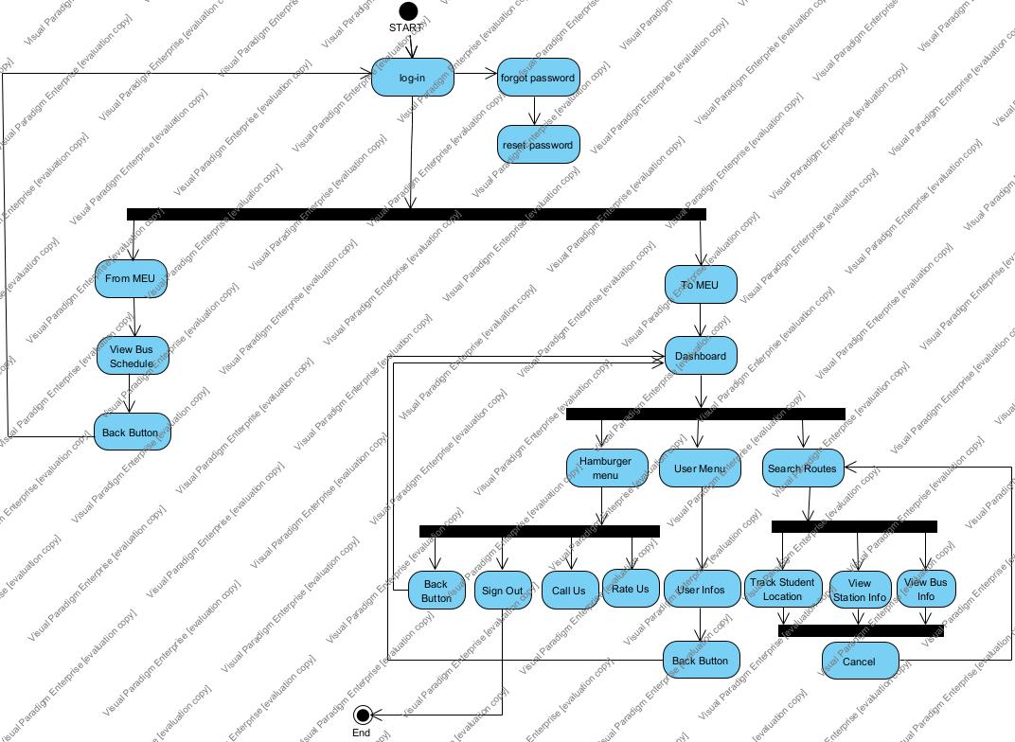

Driver Activity

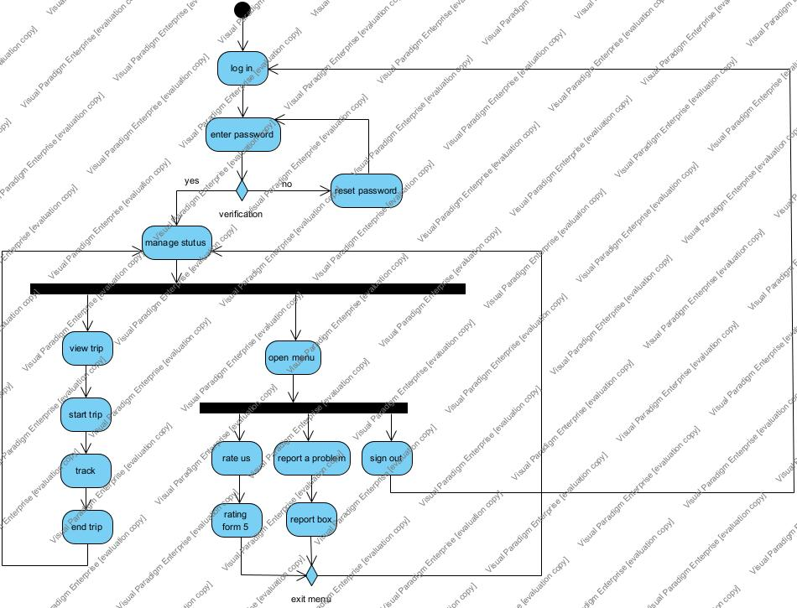

Admin Activity Diagram:

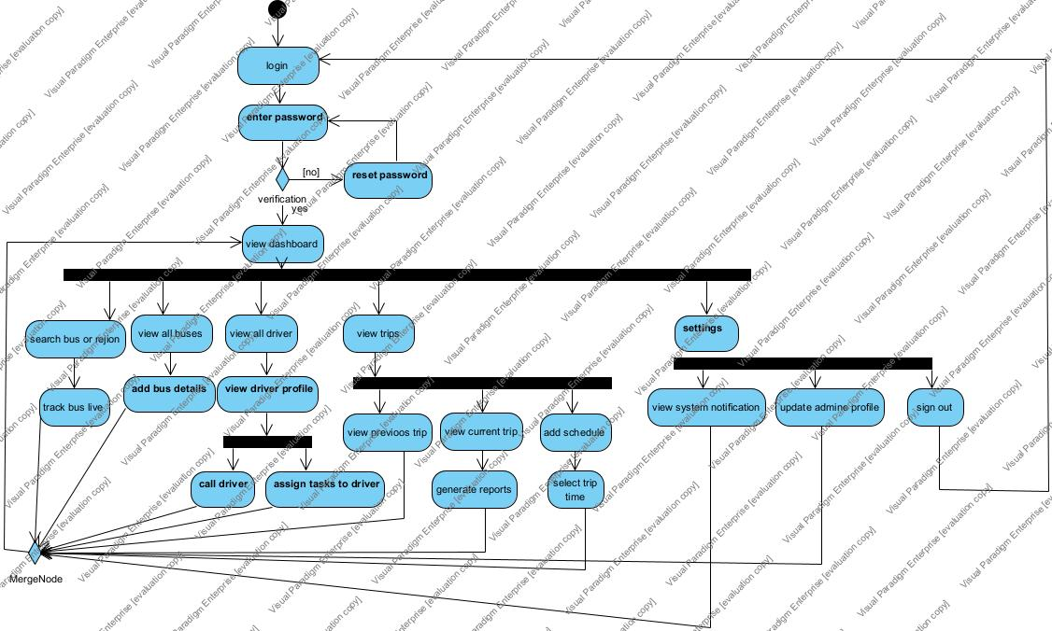

5.3 Domain Class Diagram:

Student Domain Modeling:

Identify Objects and Classes
Noun / Phrase | Category
student | Role Played
loginSession | Event
verificationCode | Event
busSchedule | Conceptual
route | Conceptual
busStop | Tangible
location | Attribute
profile | Tangible
MenuOption | Tangible
Map | Tangible

Remove Inappropriate Classes
Class | Description
student | A person who uses the app to view bus schedules, routes, and manage their profile.
loginSession | Represents a login attempt including time and status (success or fail).
verificationCode | A temporary code was sent to the student for password recovery.
busSchedule | Represents a published schedule showing when buses arrive/depart.
route | A path that a bus follows with ordered stops and estimated time.
busStop | A physical location where the bus picks up or drops off students.
location | Represents GPS coordinates of either a student or a stop.
profile | Contains student’s personal details like major, picture, and home location.

Identify Attributes per Class
Class Name | Attributes
student | studentID, name, email, password
loginSession | sessionID, loginTime, status
verificationCode | code, expirationTime
busSchedule | scheduleID, departureTime, arrivalTime
route | routeID, name
busStop | stopID, name, location
location | latitude, longitude
profile | major, homeLocation, profilePicture,phonedNumber

From Class | To Class | Relationship / Meaning | Multiplicity
student | profile | has | 1..1
student | loginSession | initiates | 1..*
student | verificationCode | receives | 0..1
busSchedule | route | includes | 1..1
route | busStop | contains | 1..*
busStop | location | Located as | 1..1
profile | location | Has | 1..1

Driver Domain Modeling:

Identify Objects and Classes
Noun / Phrase | Category
Driver | Role Played
Trip | Conceptual
Dashboard | Conceptual
Navigation | Conceptual
Authentication | Event
ResetPassword | Event
ProblemReport | Conceptual
Station | Tangible
Bus | Tangible
Menu | Conceptual
Administrator | Role Played
Login | Event

Remove Inappropriate Classes
Class | Description
Driver | Represents the user (driver) of the system who logs in, performs trips, and submits problem reports.
Trip | Represents a transportation task assigned to a driver, including route details, timing, and associated
Bus | The physical vehicle used by the driver to perform the trip and transport passengers.
Station | A designated stop or point along the trip route where the bus is scheduled to pass.
Navigation | Handles real-time tracking and display of the driver’s current location, trip progress, and next station.
ProblemReport | A record submitted by the driver to report an issue encountered during a trip.
Administrator | The system administrator responsible for assigning trips and managing drivers and buses.

Identify Attributes per Class

Class Name | Attributes
Driver | driverID, name, phoneNumber, email, username, password, status
Trip | TripId,route,startTime,endTime,status,assignedBusld
Bus | busID, plateNumber, capacity, currentLocation,
Station | stationID, name, location,orderInTrip
Navigation | tripID, liveLocation, nextStation, progressMap
ProblemReport | reportID, driverID, description, timestamp
Administrator | adminID, username, password,email

From Class | To Class | Relationship / Meaning | Multiplicity
driver | trip | association | 1..*
trip | station | composition | 1..*
trip | bus | association | 1..1
trip | navigation | aggregation | 1..1
driver | problemReport | association | 1..*
administrator | trip | association | 1..*
bus | station | association | 1..*

Admin Domain Modeling:

identify Objects and Classes
Noun / Phrase | Category
Bus | Tangible
Driver | Role Played
Trip | Event
Schedule | Conceptual
Task | Conceptual
Notification | Conceptual
Report | Conceptual / Output
Map | Tangible
Administrator | Role Played
Phone Number | Attribute
Password | Attribute
Email | Attribute
Passenger Count | Attribute
Capacity | Attribute
Destination | Attribute
Trip Time | Attribute
Status | Attribute

Remove Inappropriate Classes

Class | Description
Administrator | Represents the system administrator who manages buses, drivers, trips, schedules, and notifications. The admin can log in, update their profile, assign tasks, and generate reports.
Bus | Represents a university shuttle bus. It stores key details such as bus number, destination, capacity, live passenger count, operational status, and notes (e.g., maintenance or fuel).
Driver | Represents a driver assigned to a bus. Contains the driver’s name, phone number, current status (active/inactive), and any administrative notes.
Trip | Represents a single bus trip. Includes information such as destination, trip time, current location, and the number of passengers onboard.
Schedule | Represents the predefined time and assignment for trips. Includes the scheduled trip time, destination, and bus number assigned.
Task | Represents a specific task or assignment given to a driver, such as performing a trip at a particular time or going to a specific destination.
Notification | Represents alerts sent to the admin. Notifications may include warnings about delays, violations, low fuel levels, or any critical issues.
Report | Represents a generated report summarizing past trip data, performance metrics, or operational statistics.
Map | Represents the real-time interactive map displaying live bus locations, stop points, and supporting search, zoom, and pan functionality.

Identify Attributes per Class

Class Name | Attributes
Administrator | username, password, email, phoneNumber
Bus | busNumber, destination, capacity, livePassengers, status, notes
Driver | name, phoneNumber, status, notes
Trip | tripTime, currentLocation, passengerCount
Schedule | tripTime, destination, busNumber
Task | description, assignedTime
Notification | message, type, timestamp
Report | generatedDate, tripSummary
Map | region, zoomLevel (optional), busMarkers

From Class | To Class | Relationship / Meaning | Multiplicity
Administrator | Bus | manages | 1..*
Administrator | Driver | manages | 1..*
Administrator | Trip | oversees | 1..*
Administrator | Notification | receives | 1..*
Administrator | Report | generates | 1..*
Bus | Trip | used in | 1..*
Trip | Schedule | Has | 1..1
Driver | Task | assigned to | 1..*
Map | Bus | displays | 1..*

Class Diagram:

Student Class

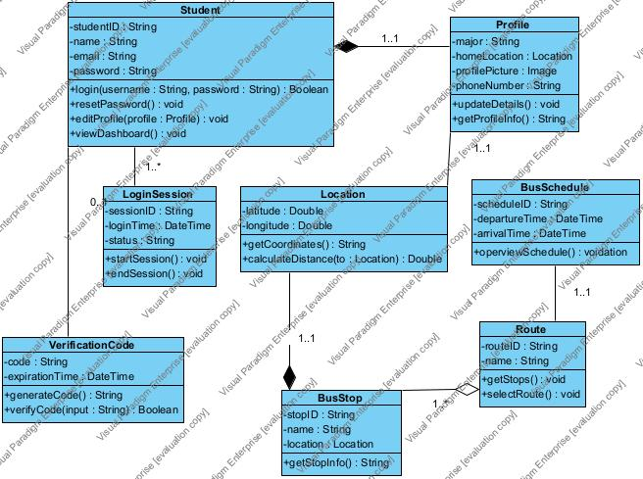

Driver Class

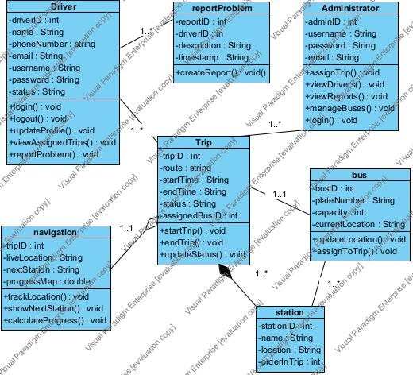

Admin Class

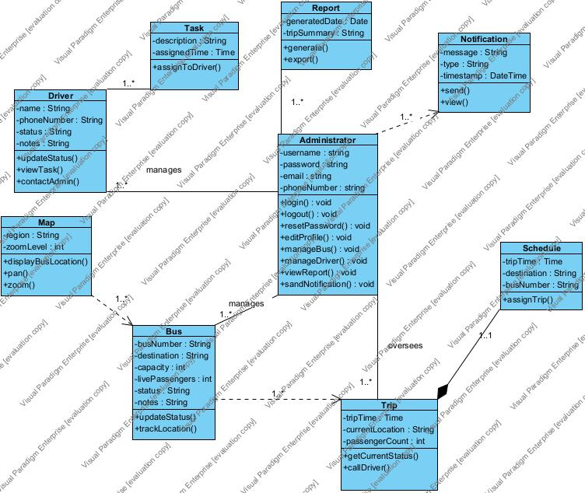

Prototype:

Student App:

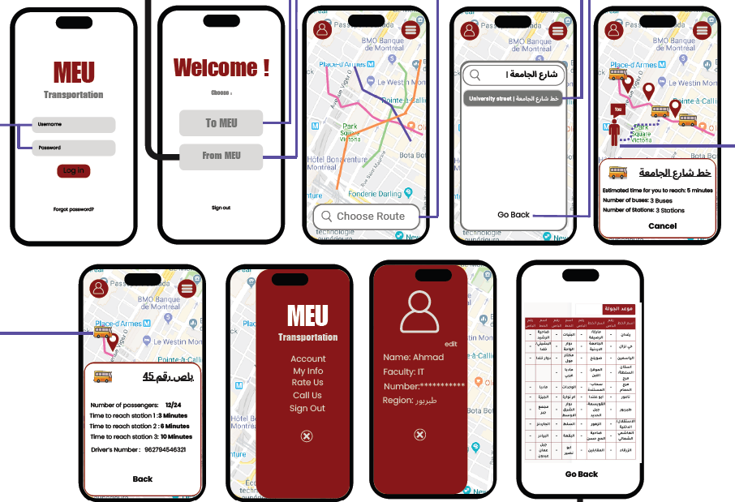

Driver App:

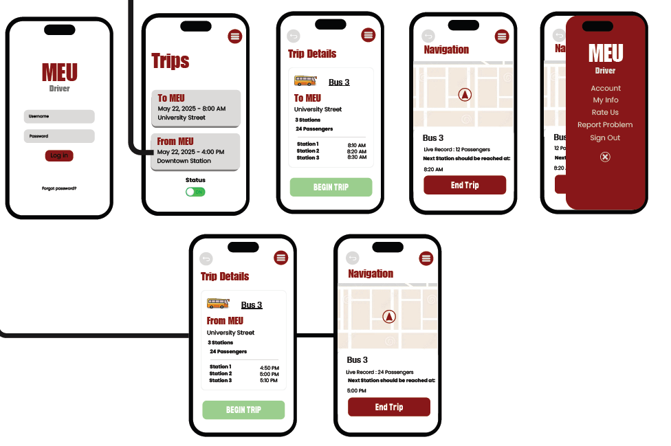

Admin App:

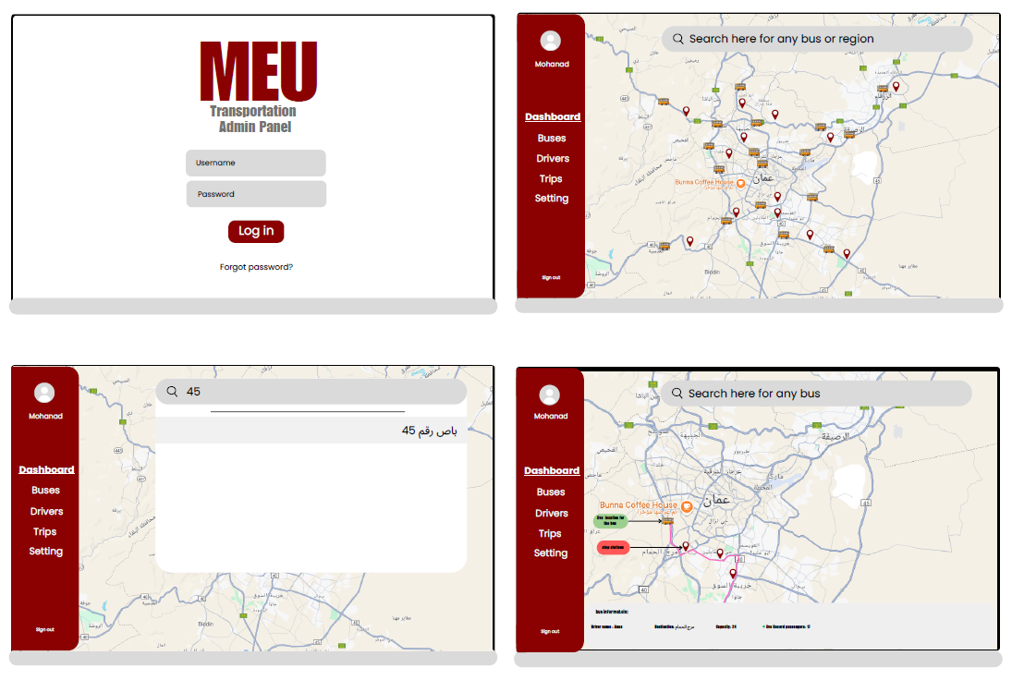

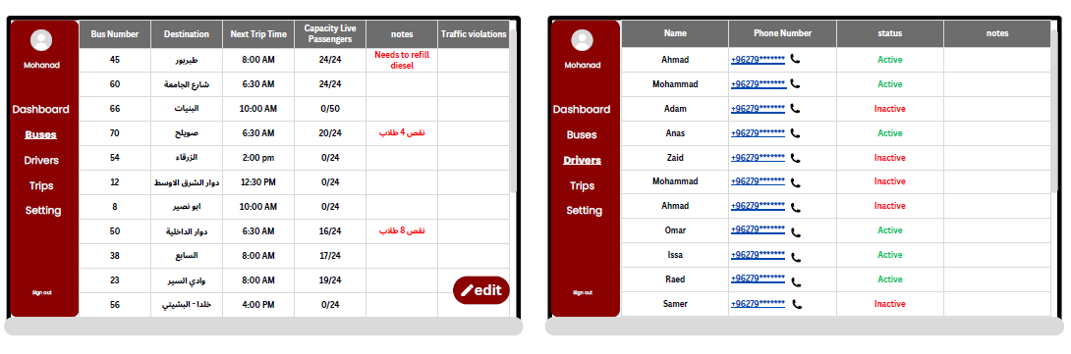

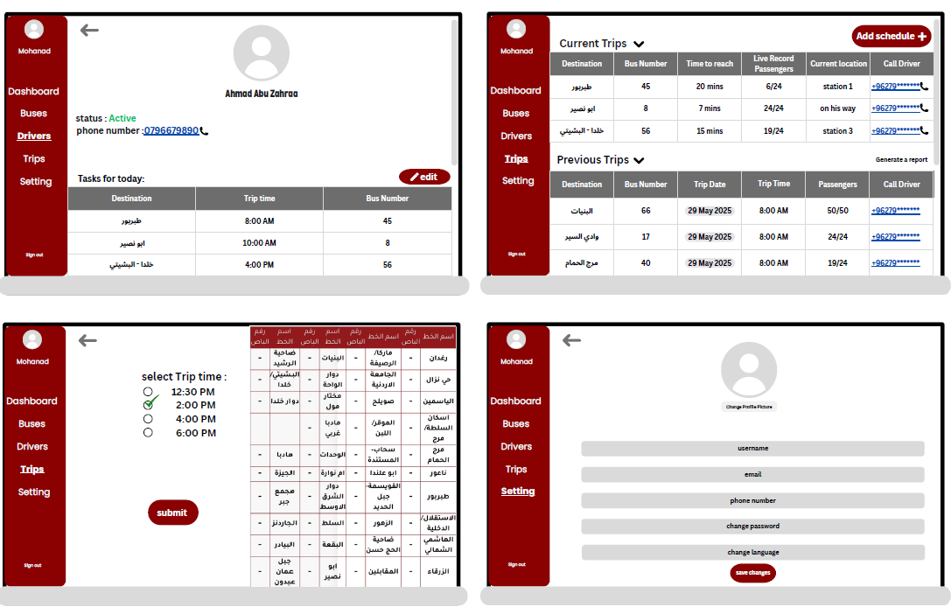

The Full Design

References:

- IEEE Software Engineering Standards Committee, “IEEE Std 830-1998, IEEE Recommended Practice for Software Requirements Specifications”, October 20, 1998.
- Feldt R., re_lecture5b_100914, unpublished.
- Davis M. A., Just Enough Requirements Management: Where Software Development Meets Marketing, New York, Dorset House Publishing, 2005.
- Karlsson J., A Cost-Value Approach for Prioritizing Requirements, Norges Teknisk-Naturvitenskapelige Universitet, 1997.
- [9:13 am, 03/06/2025] Mohammad Toubeh: IEEE Software Engineering Standards Committee, “IEEE Std 830-1998, IEEE Recommended Practice for Software Requirements Specifications”, October 20, 1998.
- Feldt R., re_lecture5b_100914, unpublished.
- Davis M. A., Just Enough Requirements Management: Where Software Development Meets Marketing, New York, Dorset House Publishing, 2005.
- Karlsson J., A Cost-Value Approach for Prioritizing Requirements, Norges Teknisk-Naturvitenskapelige Universitet, 1997.
- Kumar, S., & Bansal, M. (2019). Real-Time Smart Campus Transportation Systems Using GPS and Mobile Applications. International Journal of Computer Applications.
- Zhang, Y., Qian, Z., & Wang, L. (2020). User-Centric Transportation Applications for University Campuses: A Case Study. Journal of Urban Technology, 27(3), 67–84.
- Ahmed, S., Khan, M., & Rehman, M. (2021). Smart Transport Systems in Universities: Challenges and Opportunities. International Journal of Smart and Nano Materials.
- Uber Technologies Inc. (2023). How Real-Time Data Improves Transportation Efficiency. Uber Tech Insights. (for linking your system ideas to global standards)
- University of Michigan Transportation Services. (2022). Campus Bus Tracking System Overview. University of Michigan Official Site.
- Papageorgiou, M. (2003). Applications of Automatic Control Concepts to Traffic Flow Modeling and Control. Springer-Verlag.
- Google Developers. (2024). Google Maps Platform Documentation. Retrieved from https://developers.google.com/maps/documentation

- Firebase. (2024). Firebase Realtime Database and Firestore. Retrieved from
- https://firebase.google.com/docs/database

- Bass, L., Clements, P., & Kazman, R. (2012). Software Architecture in Practice (3rd ed.). Addison-Wesley.

- Jacobson, I., Object-Oriented Software Engineering: A Use Case Driven Approach. (1992). Addison-Wesley.

- Pressman, R. S., Software Engineering: A Practitioner’s Approach (8th ed.). (2014). McGraw-Hill Education.

- ISO/IEC 25010. (2011). Systems and software engineering — Systems and software Quality Requirements and Evaluation (SQuaRE) — System and software quality models. International Organization for Standardization.

- Wang, Y., Wu, J., & Lin, X. (2020). A Review on Urban Public Transport Accessibility Metrics. Journal of Transport Geography, 85, 102702.

- Mohapatra, S., & Mohanty, P. (2015). Mobile Computing: Technology, Applications, and Service Creation. CRC Press.

- National Institute of Standards and Technology (NIST). (2023). Framework for Improving Critical Infrastructure Cybersecurity. NIST.

- Zhao, J., Rahman, A., & Lu, H. (2017). Smart Transportation Systems: An Overview. Journal of Advanced Transportation, 2017.

Thank You

